William S. Hart on DVD: The Return of Draw Egan
Bill West
Howdy Compadres! It’s time once again to review another William S. Hart movie, available on DVD. This time, it’s the 1916 flicker “The Return of Draw Egan”, available on DVD-R format from Grapevine Video at (602) 973-3661 or at www.GrapevineVideo.com. Since the movie is only 51 minutes long (and that’s the complete uncut version -- it has been available elsewhere in shortenend form), they include a comedy short called “Droppington’s Family Tree” staring Chester Conklin. Grapevine’s copy of the Hart film has fine music, and features a tinted negative with some blue and sepia scenes.
Before I get too far ahead of myself, I’d like to make a correction to the last newsletter’s grid of William S. Hart movies. I failed to include that “Hell’s Hinges” is available from amazon.com and elsewhere, as part of the Treasures From American Film Archives set. Please get a sharp pencil and fix that for me, wouldja? :) Now back to our feature presentation....
In The Return of Draw Egan, the action takes place in a couple of those wonderfully named old west towns; in this case the towns of “Broken Hope” and “Yellow Dog.” Two-gun Bill plays a man pretending to be a Marshal to hide from his past. The picture is chock full of action, including lots of fast riding, saloon brawling, and classic shootout at the end between Hart and the bad guy. That bad guy was played by Robert McKim, who had several roles, most famously, the rival of Douglas Fairbanks in “The Mark of Zorro” in 1920.
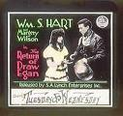
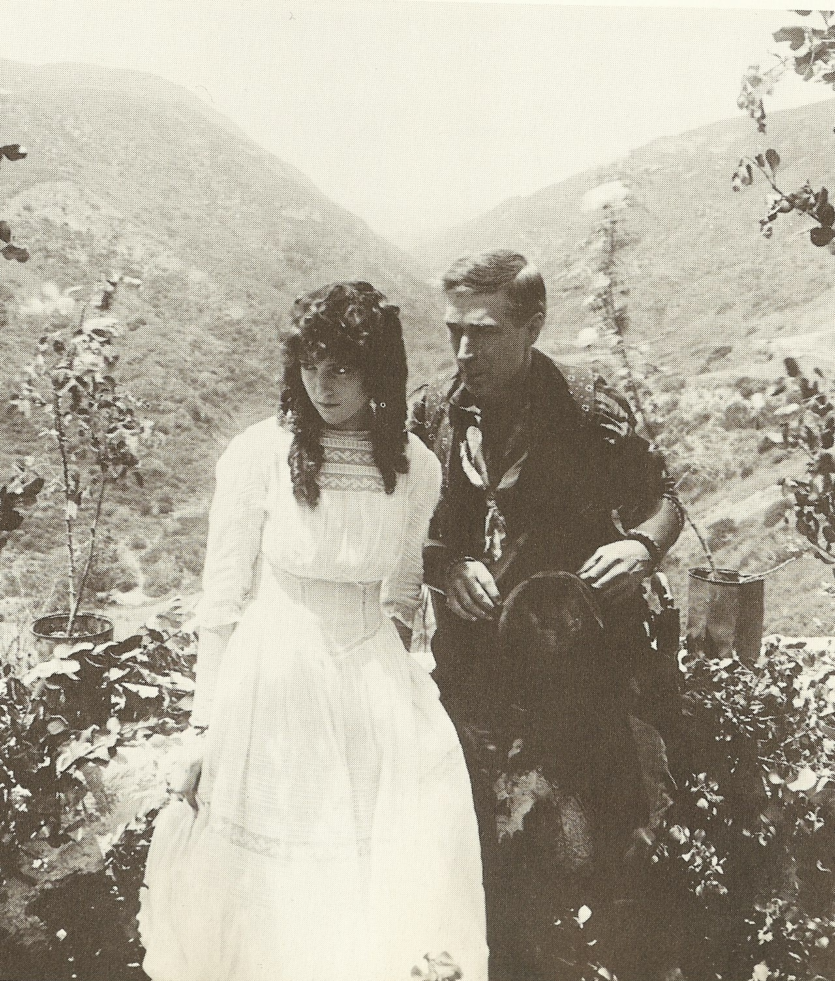
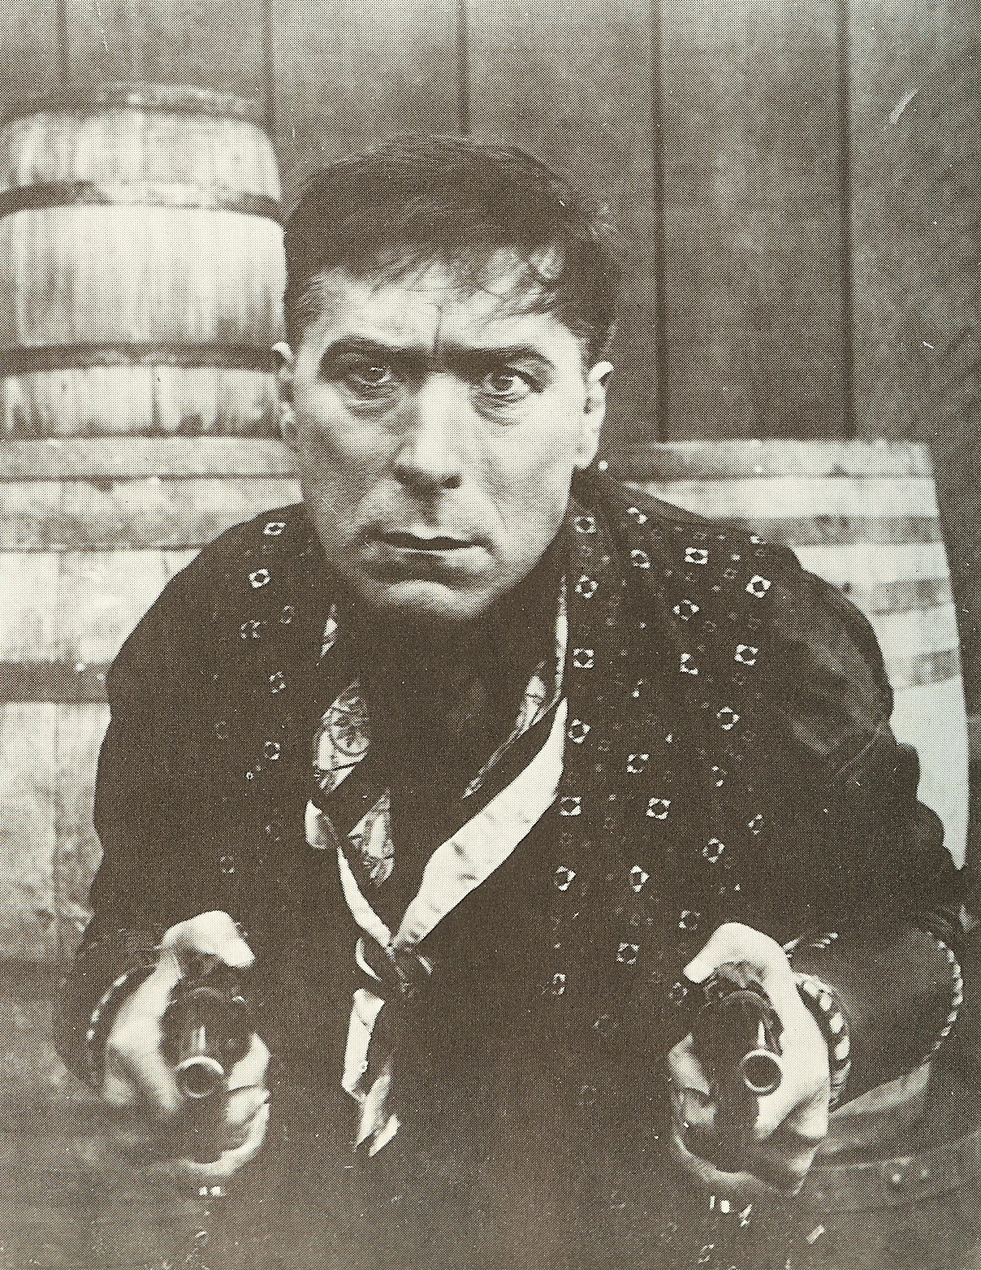
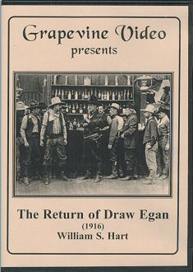
Of course, like many Hart movies, Bill starts out as a bad guy himself, only to be brought to redemption by the love of a kind, understanding woman. In this case, the woman is played by Margery Wilson, who was 20 at the time of filming, to Hart’s 51 years.
Another actress in the picture, an evil temptress who tries to draw Bill into perdition, was played by Louise Glaum, the silent era’s famous vamp known as the “spider woman.” She played in several of Bill’s films.
The picture -- written by C. Gardner Sullivan who wrote many of Hart’s films, and directed by Hart himself -- was filmed in one month in the spring of 1916, and cost $13,000 to make. However, Bill was only getting $250 per week from producer Thomas Ince, and was none too happy about it. Still, despite receiving offers from other studios as high as $5,000 per week, Bill stayed loyal and continued at “Inceville”, Thomas’s studio.
Bill didn’t suffer in silence, however. He complained to Ince who had been promising him more money for some time. Shortly after this movie was made, Ince finally agreed to $1,000 per week salary, still less than Bill could have gotten elsewhere.
The Return of Draw Egan was popular, like most of Bill’s movies. The New York Times review said it was “better than most films of its type, because it tells a reasonable story.[... ] [Hart] can draw a gun with the best road agents of fiction now, can roll a cigarette with one hand and strike a match on his nails with the nonchalance of Will Rogers.” I agree. This is one of my favorites, perhaps mostly because of some wonderful humor employed in the title cards. Additionally, there is some great camera work during the chase scenes, Fritz is featured a lot, and Hart really does roll a cigarette with one hand!

